
Capstone Project - Strut

Group 6

Assignment 2

Moegamat Tashreeq Waggie

Jamie Lee Van Der Berg

Khuliso Sikhwivhilu

Areeb Royeppen

Dean Ockhuizen

Dahraan Abrahams

Moegamat Ismaeel Ed'rees Jefferies
Three Conceptual Models
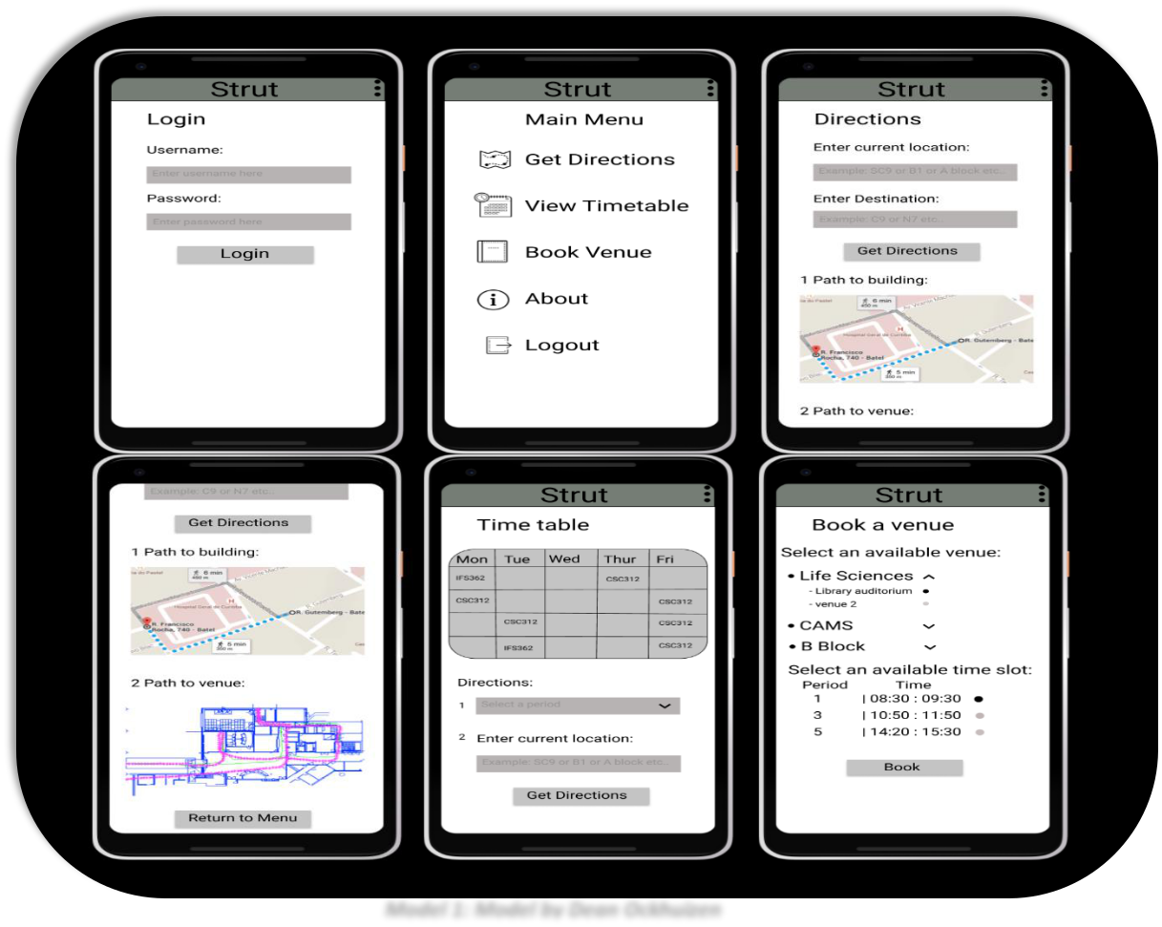

Model 1: Model by Dean Ockhuizen
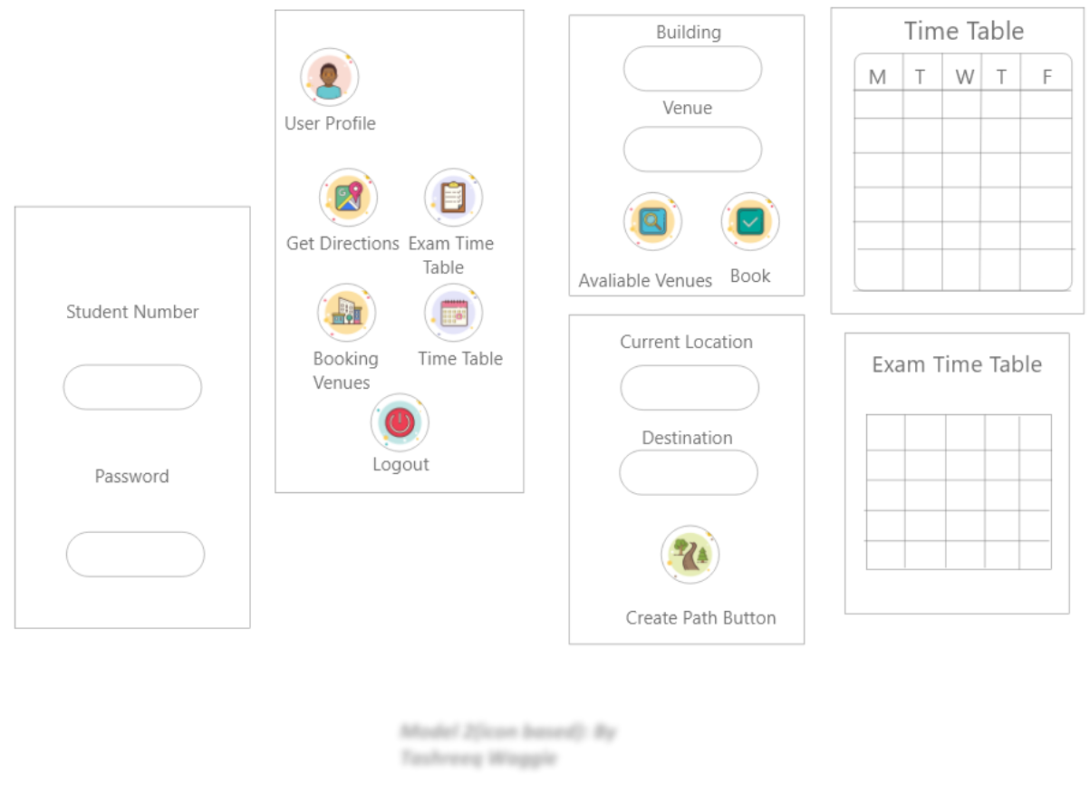

Model 2(icon based): By

Tashreeq Waggie

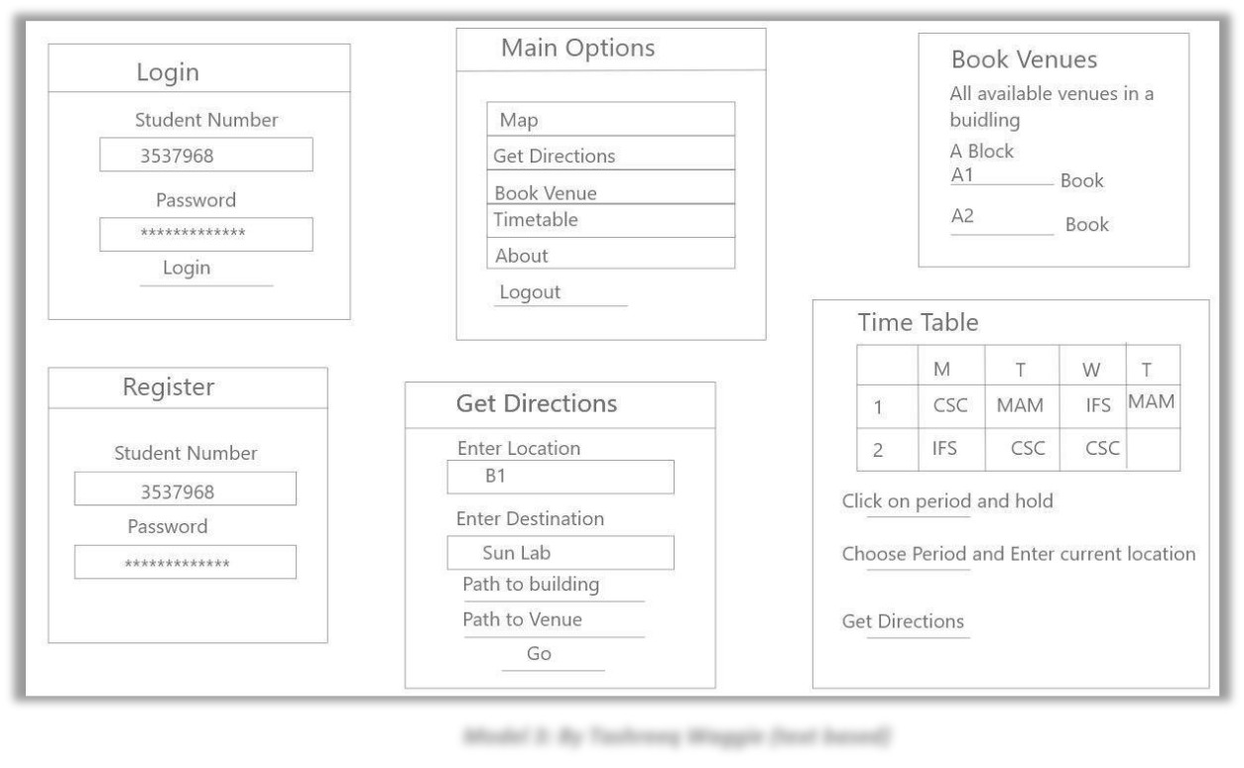

Model 3: By Tashreeq Waggie (text based)

Interface Metaphors

- The Map Metaphor evokes an initial mental model in users dating back to physical maps used to find directions before GPS.

- The Schematic Metaphor is one that users, especially students, deal with more often than they will know. For example; in the CAMS building at UWC, each floor has a schematic on the wall mapping out the floorplan. This is often used by students to gain a perception of new buildings and their venue’s.

- The Timetable Metaphor depicts a softcopy approach to the timetable students receive on the day they register for class. This is especially useful in app since print timetables are large and require the user to constantly carry it around when starting out a new semester. This of course is solved by students being able to consult their cell phones (a device they always seem to have by their side).

Interaction Types and activities

- Manipulating: Users explore the in-app map in order to find their way similar to real physical maps. This is used to generate paths for directions on campus between venues/buildings.

- Instructing: Users explore the app by buttons to access the various options and enter location and destination information in order to get directions. Users also instruct app to query available venues for booking, timetable query, exam timetable query (Model 2) and login and logout.
Interface Type

Mobile - Handheld devices are portable and have become daily drivers in end users lives, especially in the lives of students. With this in mind, students will be able to use the app wherever they happen to be on campus.

Functions

- Allow students to login and logout

- Allow users to get directions from one venue/building to another venue/building

- Display paths to users (superimposed on map)

- Display building floor schematics

- Allow students to display timetable and generate paths/directions to specified class

- Allow students to book venues

- *Allow students to view exam timetable (Applicable to model 2)

Function Relationships

- A student must login before being able to display his/her timetable

- A student must login before being able to book a venue

- A student must login before being able to display their exam timetable (Applicable to model 2)

- A user must enter an origin and destination before being able to display a path and map

- A path to a building must first be generated before being able to display the building schematic.

Information Requirements

- For login purposes

  - Student Number o Password

- In order to display a student’s timetable, we need access to UWC’s existing student database for module querying to build a timetable per student upon login

- In order to display the exam timetable, we will need access to the UWC’s examination dates (Model 2)

- Google Map API for displaying google places (buildings/venues on campus in our case)

Reason why a specific conceptual model was chosen

We decided that Model 2 would be best suited for our app. The model was most applicable since it had the strengths from both model 1 and 3 incorporated. Model 2 best fits our interface metaphors and adds functionality for viewing exam timetables. Of the three it is also the most aesthetically pleasing and from this model we can build an app that reduces frustration and learning burden on the user’s part through interactions with buttons.
Storyboard prototype
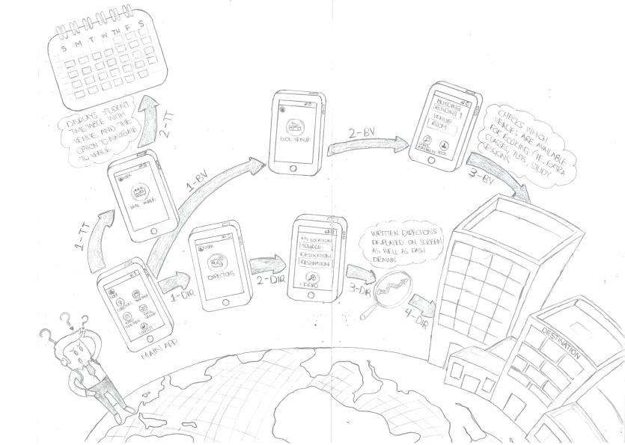

Feedback

We made users read our story and below are a few things the user saw could be better.

- User didn’t know whether an individual that a student is not can make use of our mobile application as well. Create a screen that will allow user to be a visitor to just make use of the ‘Get direction’ screen.

- User ask how the student would make use of the app since every student has different degrees and modules so create a login screen for students using student number and their already made passwords.

- Timetable: We should make it visible that student would be able to get direction to class directly from the timetable screen by implementing a button.

- Should make it clear that student can get directions to exam venues from the exam venue screen by implementing a button.
Cardboard prototype
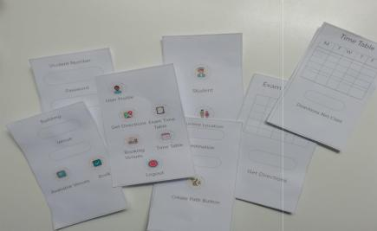

Feedback

For the feedback we had a user interact with the cards and perform tasks as if he was on actual mobile application. Below are a few things the user saw could be better.

- Back Button: The users made it immediately clear that we do not have a back button (Something we the creators of the application should have realized earlier).

- Timetable screen: User suggested why not just create a path to class when just tapping on a specific period.

- Get Direction screen: They would have like if a background of a map was adding, something similar to google maps for getting directions.

- The naming of buttons can be done better (grammar) and more to the point.

- Exam Timetable: Student should be able to get direction to an exam venue directly from the exam timetable screen by taping on the module, making it convenient for users.

Sketch of applications main screen
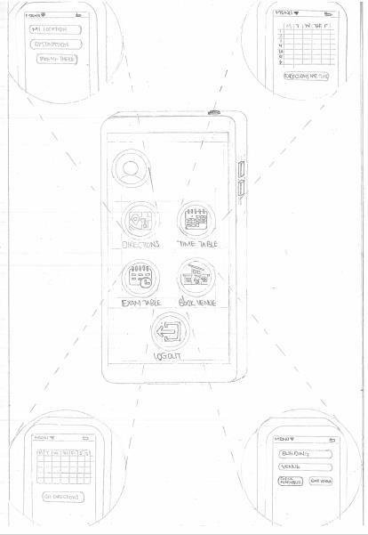

Where am I?

This is the home (main) screen that the student will see after logging in using their credentials. The home screen will be one of the most interactive and allow for students to navigate through the mobile application.

What’s here?

On the home screen there are 5 different buttons (which are icons). These buttons are labelled as followed – ‘Directions’, ‘Time Table’, ‘Exam Table’, ‘Book Venue’, ‘Logout’ and lastly a user profile in the top left corner. They will take users to their respective screens for functionality depending on which icon button was pressed. The layout is simple and pleasing. It’s not cluttered, and users won’t get irritated with the home (main) screen. Lastly there is a user profile in the top left corner.
--------------------------------------------------------------------------------------------------------------------------

(You can read this if you want)

- Directions: An icon button labelled ‘Directions’ where the user clicks and takes the user to a different screen for getting paths to class. where they can enter their locations and destination(venue/building) that they would like to get a path to.

- Timetable: An icon button labelled ‘Timetable’ where the user clicks and takes the user to a different screen to check their timetable. where they can view their timetable and get directions to a specific class

- Exam table: An icon button labelled ‘Exam Time’ where the user clicks and takes the user to a different screen where they can see their exam table only related to their specific modules.

- Book Venue: An icon button labelled ‘Book Venue’ where the user clicks and takes the user to a different screen to book venues.

--------------------------------------------------------------------------------------------------------------------------

Where can I go?

The icon buttons give the user options to go to any other screens having their own function that fits together with the overall application

- Directions button will take the user to a screen where it will allow them to enter their current location and the destination location (such as the building or venue). You can press the button “Take me there” and it will generate a path on the map.

- Timetable button will take user to a screen where it will allow them to view their timetable, and there is a button ‘Directions nxt class’ which generate a path to the venue for their next period.

- Exam Table button will take the user to a screen where it will allow them to view their exam timetable specific to their modules they are doing. On the screen there is a button

‘Get directions’ that will generate path/directions for your latest exam or any one exam venue you would like know.

- Book Venue will take the user to a screen where they will be able to check which venues are available by entering the building (optional) and the venue. Having then two buttons one for checking for availability and another to book then venue if its available.

- Lastly A logout button that will log the user out of their account and back to the login screen.
Is choice Usability or User experience

Choice is for both usability and user experience.

User experience

- It eliminates the stress of being late to lectures. One of the primary reasons why students at UWC are late to lectures is because they don’t know where those venues are. Many a times students will fall behind in their course work because they have missed lectures because of being late. This results in stress and being demotivated. It will then affect one’s health and marks later. This will lessen that burden and affect. It will hopefully help students in their academic lives and keep them on track.

Usability

- The system is laid out in the simplest possible format where everything that the students need to excess or may like to access is right in front of them. The main screens that are being used by students the most is not cluttered so they and straight to the point. We made it that so that its pleasing to look at an interact with. The buttons are icons which are more appealing to users of this day and age. When finding directions, the map shows paths as if you were looking at an atlas.
Experience map
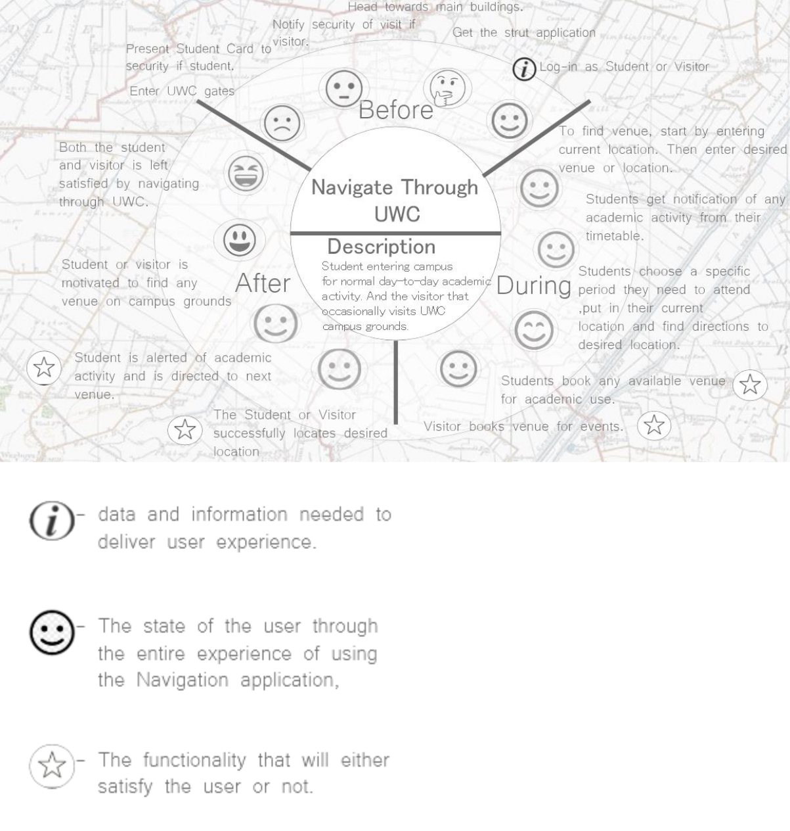

New interaction issues

- Learnability

- Multiple holds: Not having the ability to reach buttons. This is what I mean:
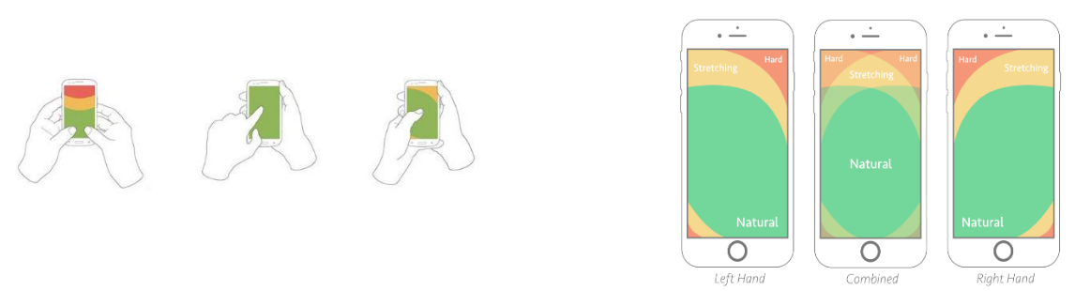
How to address them

Multiple holds - Addressing the multiple holds issues, when designing the final interface, we can move the ‘back’ bottom or most of the icon buttons further to center or closer to the bottom of the screen or create a gesture to replace it.

Learnability - We intend to create an information button on each page to indicate each page works, because in the case of Exam time table and the normal timetable users won’t know that you can actual hold/tap on your specific period or exam venue detail and it allow you to get the directions for that venue. We all most likely take the user through a tutorial during their first use of the mobile application.

How does your app relate to the Maker Movement?

Our product differs from products which come from the maker movement in that it will be refined and offer a user-friendly interface. It will offer a pleasant user experience for students/visitors who are often frustrated with the concern of being late or unable to find a venue. The product will have understand-ability, reliability and security, these are traits not often found in DIY type products which typically emerge from the Maker Movement.

What is the role of SDKs in this regard?

The role of SDKs is to facilitate the transition from designing to construction. The SDKs enable us to implement the aforementioned traits into our product because, they make the development process easier by including things like: Integrated development environment, documentation, drivers, and application programming interfaces (APIs) and more things which facilitate the construction of applications

Assuming AgileUX, what goes into Cycle 0?

Cycle 0: The data collection from user profiles and the interviews with them has revealed that most potential users of the application have very little time to access and use the application. The application has to have a familiar and simple interface and produces detailed and non-complicated directions to the desired venues of the users as a primary function of the application. Secondary functions of the application need cater for the linking between student modules and their timetables. Please refer to the final prototype of the application for the overall design of the application.
Prioritise the requirements:
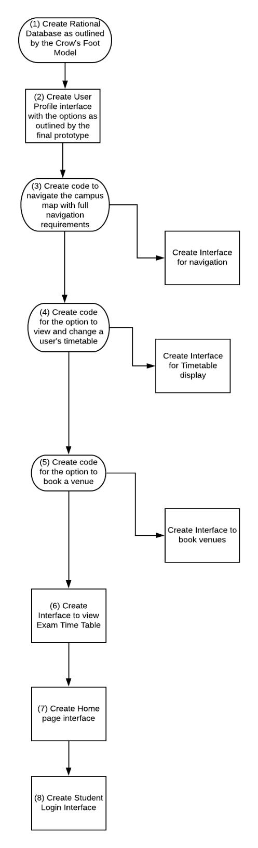
Sketch 4 cycles e.g. Cycle 0 and Cycles 1-3.
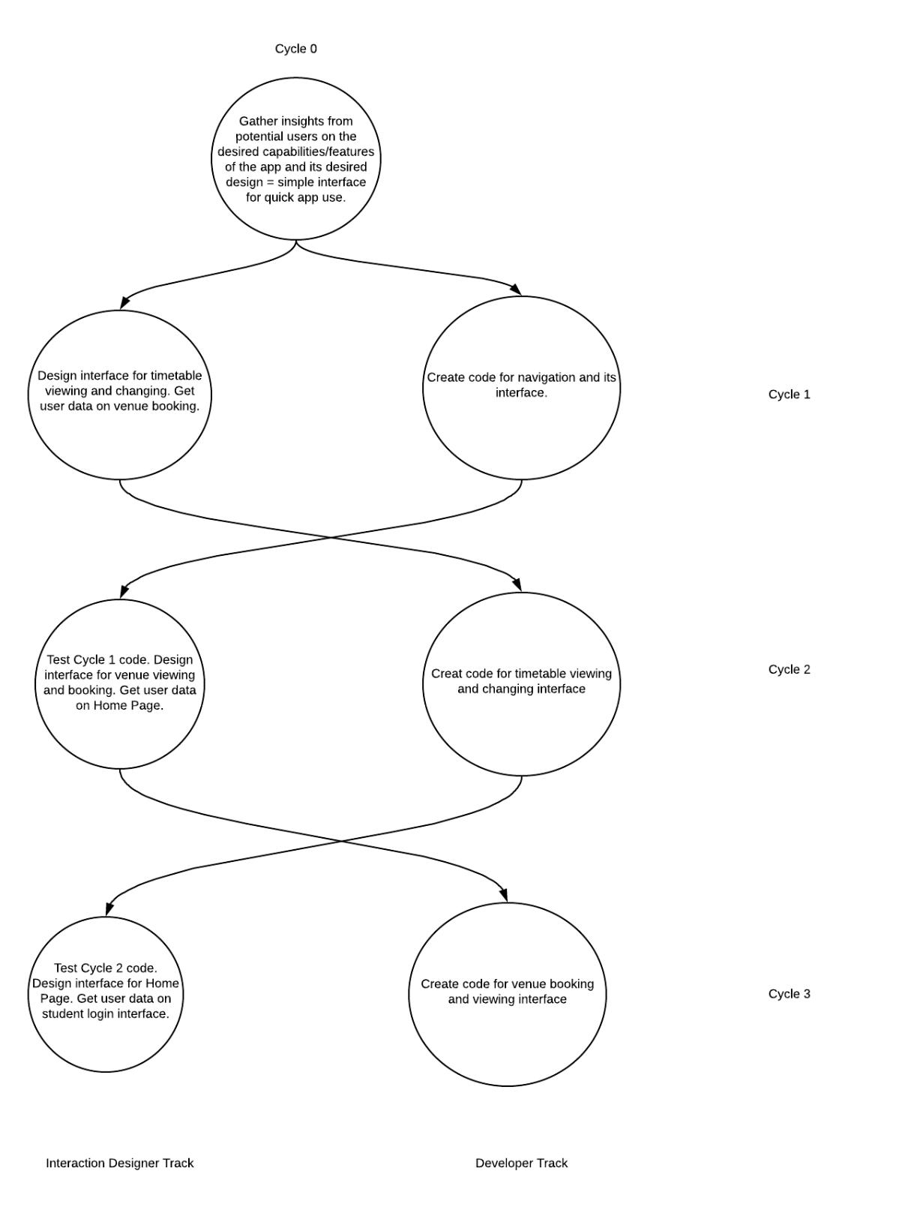

Mockup of landing page (Horizontal)

Link - https://xd.adobe.com/spec/172e9885-670e-4168-5761-0f64ddba511a-611f/
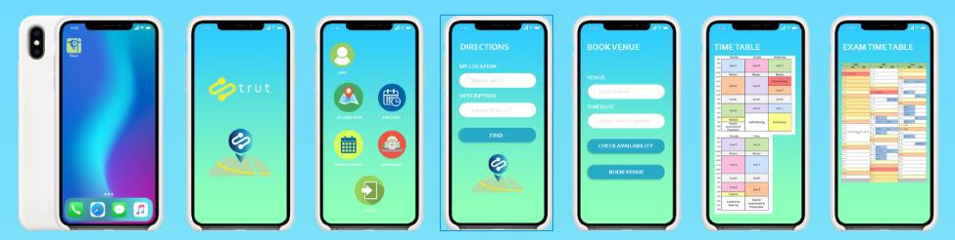

Prototype with Design Patterns

Link to final prototype with design patterns- https://xd.adobe.com/view/f8812077-f980-44fd-7169-11cc466511f2-8eb0/?fullscreen

Looking at our app there are two design patterns that come to mind which is Creational and Structural design patterns. In the case of Creational it will be our prototype that we are currently working on (above line). We are basically creating a copy of another application. We intend to let student find their venues on campus which is similar to google maps. In the case of structural, the app would be composite in that our main screen branches off into many other screens that has different functionality but to get to those screens you need to make use of the main screen. Just in the case of generating a path to find your venue you first have a screen that allows you to enter the details and takes you to another screen that displays the path.

Some analogies for structural
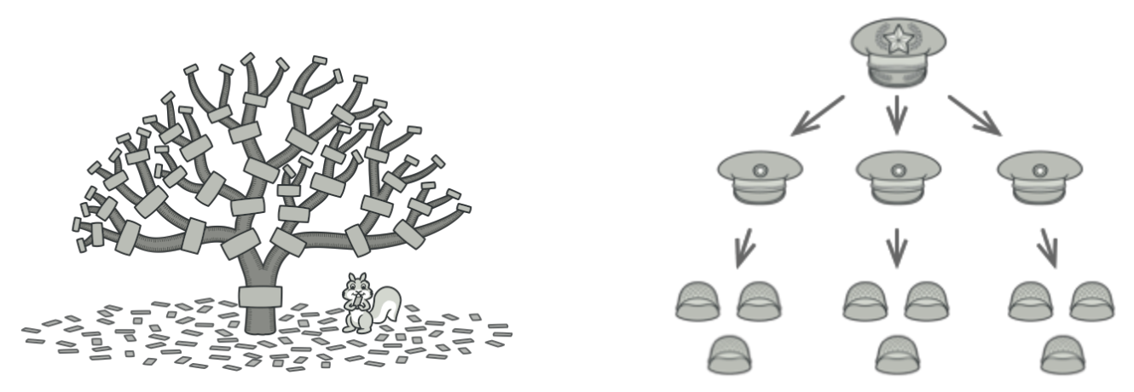
Now looking at the prototype (vertical)
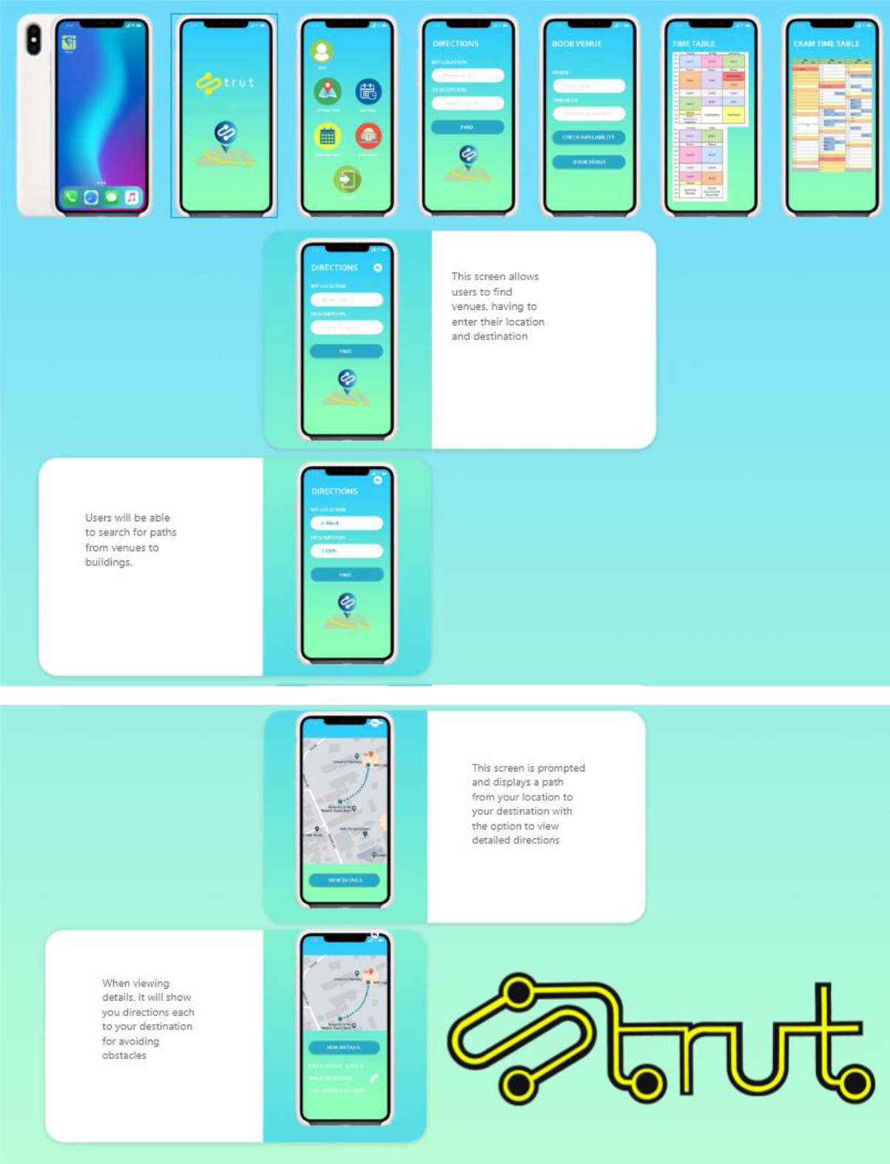
Databases

Entities

- Student

- Enrolement o Module

o Timetable o Venue

o Building

o ExamTimetable o BookedVenue

Business Rules

1 Student has M Enrolements; possibly none
1 Enrolement belongs to 1 student; not none

1 Module has M Enrolements; possibly none
1 Enrolement belongs to 1 Module; not none

1 Module is found in M Timetables; possibly none
1 Timetable contains 1 Module; not none

1 Venue is found in M Timetables; possibly none
1 Timetable contains 1 Venue; not none

1 Module is found in M Timetables; possibly none
1 Timetable contains 1 Module; not none

1 Venue is found in M ExamTimetables; possibly none
1 ExamTimetable contains 1 Venue; not none

1 Building has M Venue; possibly none
1 Venue belongs to 1 Building; not none

1 Student has M BookedVenues; possibly none
1 BookedVenue belongs to 1 Student; not none

1 Venue has M BookedVenues; possibly none
1 BookedVenue contains 1 Venue; not none

ERD
